Habitat Suitability Analysis

of Aedes Mosquitos in Brazil

# Table of Contents

Table of Contents 2

1. Background of Study 3

2. Habitat Suitability Variables of Aedes Mosquitos 3

3. Methodology 4

3.1 Data Collection 4

3.2 Data Analysis 4

4. Results 6

4.1 Historical Occurrences of Aedes 6

4.2 Variables of Habitat Suitability 7

4.2.1 Precipitation 7

4.2.2 Temperature 8

4.1.3 Population Density 9

4.3 Relationship between Habitat Suitability Variables with Aedes occurrences 10

4.3.1 Normality Test 10

4.3.2 Correlation Test 12

4.3.3 Multivariable Linear Regression Model 13

5. Discussion 14

6. Conclusion 15

7. References 16

# Background of Study

Brazil is the biggest country in South America, with an area of 8,512,000 km2. The country has a 214 million population and most of them live in urban areas. Currently, there are a total of 4140 municipalities in Brazil (World Population Review, 2021). In 2016, Brazil experienced 802,249 suspected cases of dengue fever, 63,810 conﬁrmed cases of chikungunya, and 64,311 conﬁrmed cases of Zika fever in 1840 municipalities (MS, 2019). Dengue fever, chikungunya, and Zika are primarily caused by Arboviruses which is due to the spread of Aedes aegypti and Aedes albocpitus mosquitos (Kyle and Harris, 2008; Paupy et al., 2010). Higher infestation levels of Aedes in Brazil is related with highly populated neighborhoods and tropical weather in which increase proliferation of potential mosquitos’ breeding sites (Tauil 2001, Luz et al. 2003). The weather of Brazil is tropical and this is suitable for the dissemination of zoonosis caused by arthropod-borne viruses (Figueiredo, 2003).

To prepare the country for the re-emergence of the diseases, it is crucial to understand the historical distribution of Aedes occurrences and measuring the potential risk that might be established based on habitat suitability variables. Therefore, this study aims to map and model Aedes habitat suitability through the following objectives: (1) map the risk based on historical Aedes mosquitos occurrences, (2) map the environmental suitability variables and (3) develop relationship model to know how habitat suitability variables influence Aedes mosquitos occurrences. The structure of this study starts with background of problem and previous study of habitat suitability variables. The methodology used and the result of the objectives will be explained in the following part. Afterward, we will discuss the high suitability area in Brazil for Aedes based on relationship model and previous scientific evidence. In the last part, there are conclusion which sum up the finding of the study.

# Habitat Suitability Variables of Aedes Mosquitos

Several authors have shown that urbanization and vegetation index have significant influence on the occurrences of Ae. aegypti and Ae. albopictus (Honório et al., 2009; Lorenz, Castro, et al., 2020). While, Aedes aegypti is more prevalent in highly urbanized and densely populated neighborhoods, Aedes albopictus is more prevalent in rural, suburban, and forested urban areas. According to (Dickens et al., 2018) high population density has performed strong positive correlation with the habitat suitability of Aedes. Socioeconomic factor such as population density, house characteristic, and household income level were also found to play a signiﬁcant role in predicting Aedes presence and abundance (Sallam et al., 2017).

In addition, previous models highlighted the influence of climate variables in predicting the global and regional distribution of both vectors, such as temperature and precipitation. (Kreamer et al., 2015a). Temperatures between 20°C and 31°C could improve the metabolic rate of mosquitoes, which leads to increased mosquito abundance when larval habitats become available (Scott et al., 2000; Araujo et al., 2015; Misslin et al., 2016; Murdock et al., 2017). Precipitation affects in increased numbers of outdoor rain-ﬁlled containers such as tires, drums and buckets (Sallam et al., 2017), where female Aedes mosquitoes usually place their eggs on those spots and remains for several days (Service 1992; Focks and Chadee, 1997; Gubler, 1998; Calderón-Arguedas et al., 2004). However, up until recently, there is no exact amount of suitable precipitation for Aedes habitat mentioned in the related studies.

# Methodology

In the Methodology part, the author explained the source of data collection and the flow of data analysis

## 3.1 Data Collection

The global occurrences of Aedes aegypti and Aedes albopictus have been compiled and published by Kraemer et al. (2015b). These previous publications provide data on the known global occurrences of Aedes between 1960 and 2014. The dataset stores 19.930 spatially unique occurrence records for Aedes aegypti and 22.137 for Aedes albopictus.

In this study, the author used average 1 kilometer squared of gridded-cell precipitation and temperature data in December from 1970 until 2000. The data were taken from WolrdClim.org version 2.1. December data for climate variable is chosen since it is the peak period of Aedes infestation (Lorenz, Castro, et al., 2020; Lorenz, Chiaravalloti-Neto, et al., 2020; Lubinda et al., 2019). In addition, this study also used world population density per grid-cell data from WorldPop.org with 1 kilometer resolution.

## 3.2 Data Analysis

This study used ArcMap version 10.3 to do mapping of Aedes occurrences and habitat suitability variables. To know the categorical level of the Aedes occurrences and habitat suitability variables, the author used *quantities classification tool*. The classification tool used is natural breaks for three categories. Since the variables (temperature, precipitation and population density) are in raster form, the author did some data processing first before going into classification. Firstly, the author did *Extract by Mask*, to clip the variables (precipitation, temperature and population density) into the Brazil boundary. Secondly, the author used *Statistic as Table*, to clip the variables data from in Brazil scale into municipalities boundary. The value of each municipality was calculated from the sum of the values in each grids divided by number of grids in one municipality. Aside of getting the spatial data in municipality level for each variable, this tool also provided the attribute table for each variables and each municipalities that can be used for the next analysis (regression model). For the mosquitos occurrences data, the author used *Spatial Joint Analysis* to clip the points of geolocation into municipality level. After that, the mosquitos data was classified with the same methodology as the other variables.

Finally, this study use R studio to do Pearson’s r correlation and multivariable linear regression analysis to know how much precipitation, temperature and population density affects the occurrence of mosquitos. Pearson’s r correlation aims to know whether there is relationship between two scale variables and to measure how strong the relationship (Healey, 2010). The author used linear regression since some previous studies (Ibáñez-Justicia et al., 2020; Omar et al., 2021; Proestos et al., 2015; Wilke et al., 2020) show that habitat suitability variables have linear relationship to Aedes occurrences. Before doing correlation and regression, the author run normality test as the both correlation and regression are parametric methods (Healey, 2010). However, if the data is not normally distributed, the data transformation would be run using square root or log. This study assigned Aedes occurrences as dependent variables while other variables are the independent variables. In the discussion part, the study performs the high suitability municipalities according to the result and literature review. The illustration on research methodology is shown in **Figure 1**.

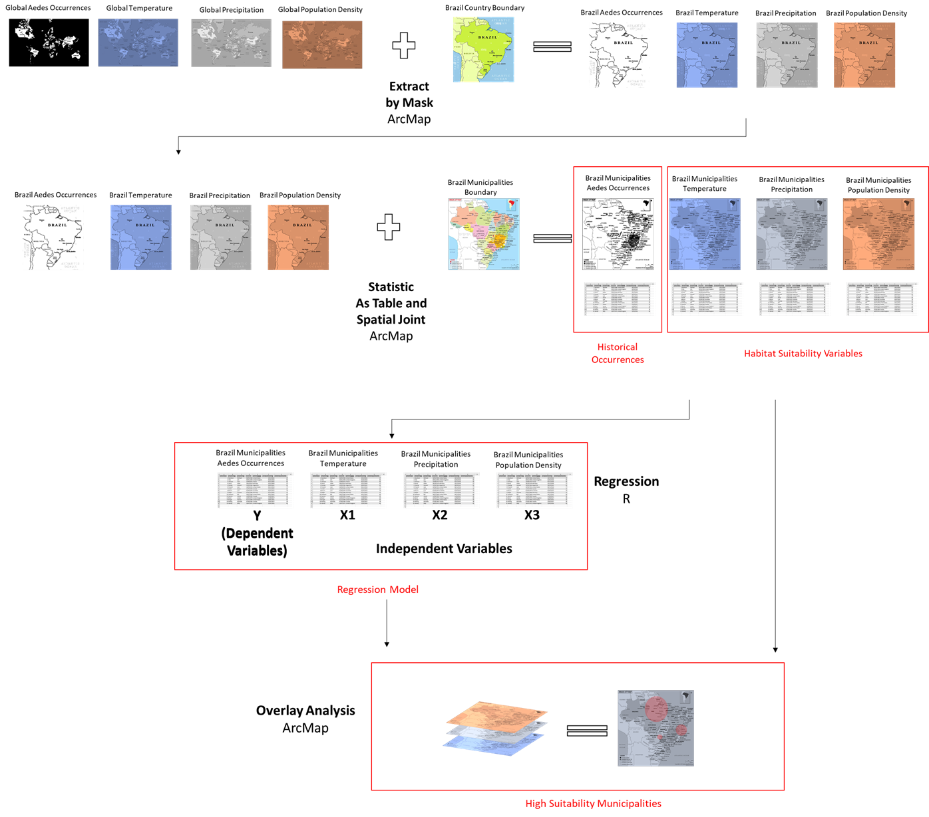

Figure Research Methodology

# Results

In this part, the author provides map of Aedes historical occurrences along with the map of habitat suitability and the relationship between them.

## 4.1 Historical Occurrences of Aedes

Figure 2 depicts the number of Aedes occurrences in Brazil from 1960 until 2014. It can be seen that most of municipalities have Aedes records range from zero to five. Rio de Janeiro, which located in the south of Brazil, records the highest occurrence with 82 records in those range of years. Nova Iguacu and Maucu, which also located in the south Brazil, stand as the second highest with 46 and 41 records in consecutive.

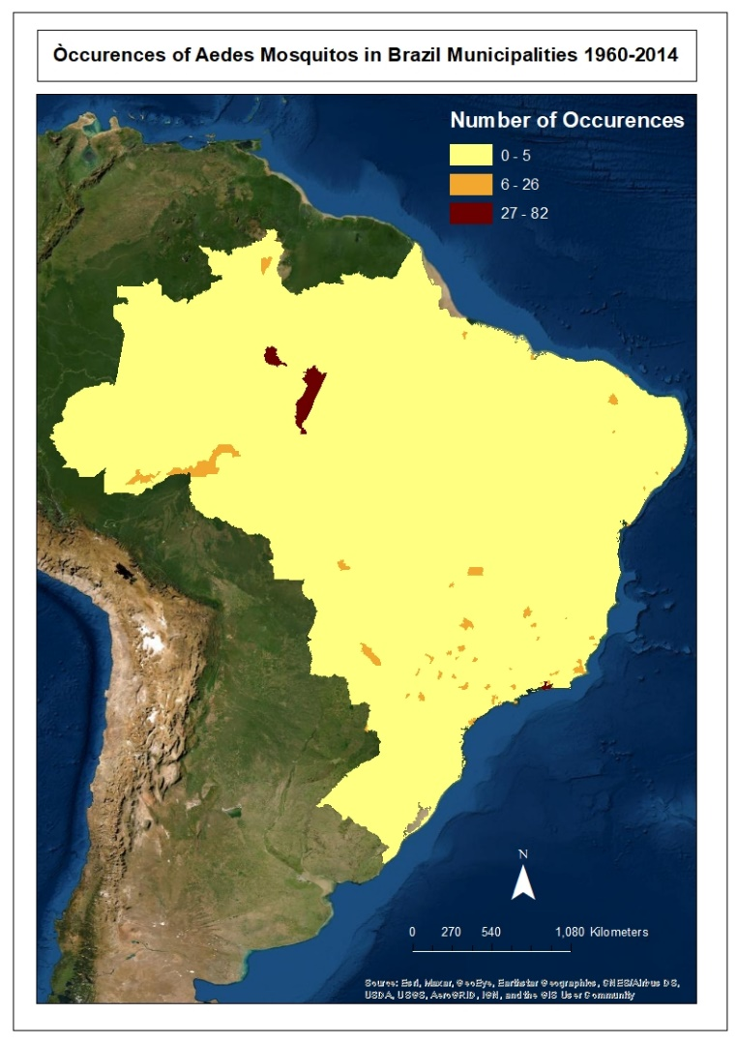

Figure The Occurrences of Aedes Mosquitos in Brazil Municipalities between 1960 until 2014

Source: Author analysis from Kraemer et al. (2015b), 2022

## 4.2 Variables of Habitat Suitability

In this part we will look at each of habitat suitability map based on natural breaks classification

### 4.2.1 Precipitation

Figure 3 presents the distribution of rainfall in Brazil Municipalities on December between 1970 until 2020. From the figure we can see that high level of precipitation takes place on the middle area of Brazil which cover 869 municipalities.

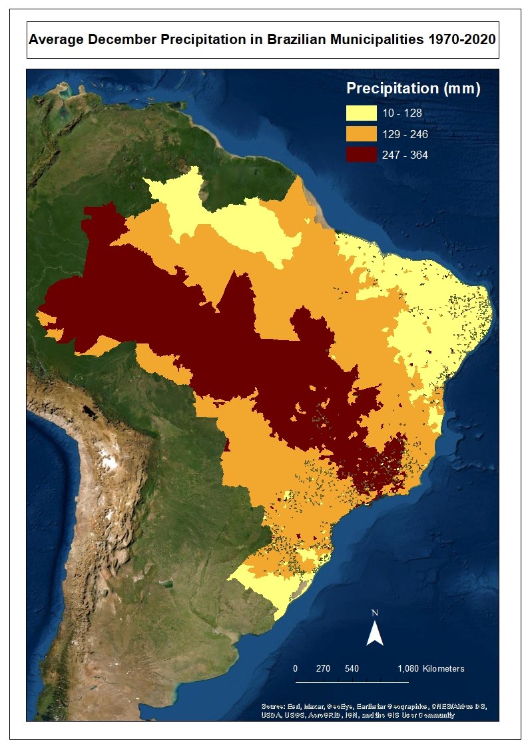

**Average Precipitation in Brazil Municipalities on December 1970-2020**

Figure Average Precipitation in Brazilian Municipalities on December between 1970 until 2020

*Source: Author analysis from WorldClim.org data, 2022*

### 4.2.2 Temperature

Figure 4 describes the average temperature in Brazil municipalities on December between 1970 until 2020. From the figure we can see that most of municipalities have mean of temperature range between 21 until 28 degree celcius.

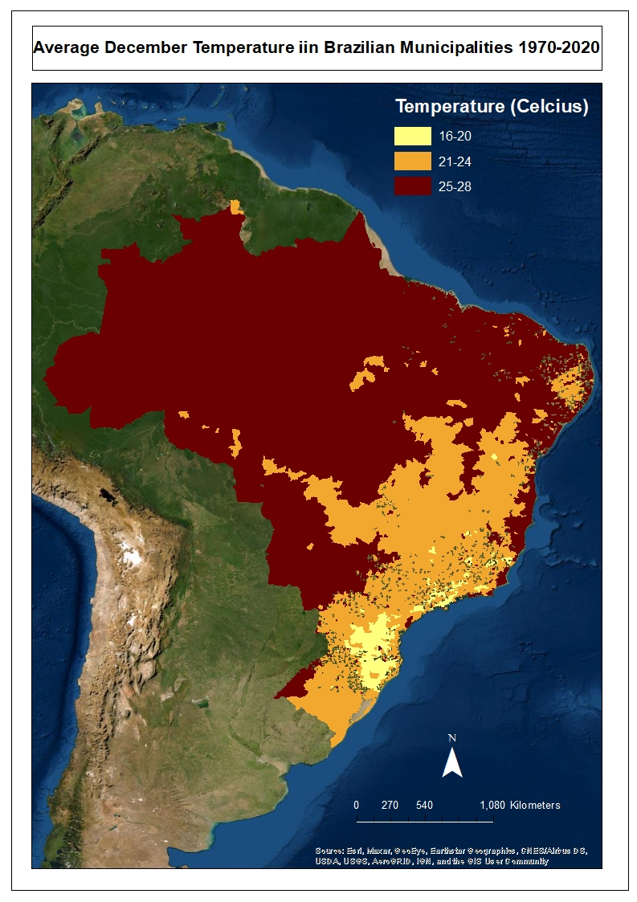

**Average Temperature in Brazil Municipalities on December 1970-2020**

Figure Average Temperature in Brazil Municipalities on December between 1970 until 2020

*Source: Author analysis from WorldClim.org data, 2022*

### Population Density

Figure 5 describes the population density in Brazil municipalities on 2020. From the figure we can see that moderate and high population density of municipalities are distributed on the coastal area of Brazil, range from 100 people per kilometer square until more than 1000 people per kilometer square.

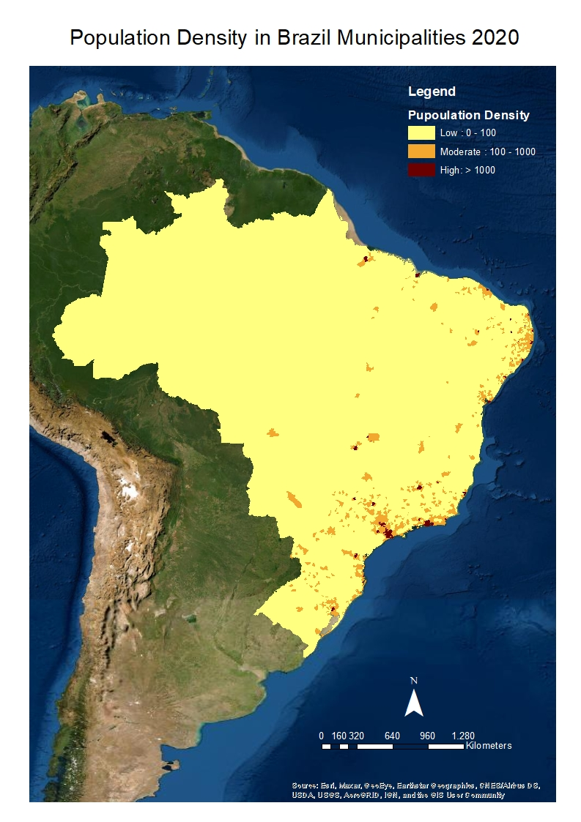

**Population Density in Brazil Municipalities on 2020**

Figure Population Density in Brazil Municipalities on 2020

*Source: Author analysis from WorldPop.org data, 2022*

## 4.3 Relationship between Habitat Suitability Variables with Aedes occurrences

### 4.3.1 Normality Test

Before doing correlation test and linear regression analysis, the author did normality check all of the variables. In case there is any not-normally distributed data, the author would transform data using log or square root.

#### 4.3.1.1 Aedes Occurrences

The summary of Aedes Occurrences (Figure 6) shows that the mean and median look similar. However, the distribution curve (Figure 7) depicts the data does not perform bell-shaped. Hence, we can conclude that the data is not normally distributed. The author did square root transformation to the occurrences data to make the data normally distributed. The square root transformation succeed to make the data normally distributed as the curve performs bell-shaped (Figure 8)

**Aedes Occurrences**

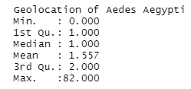

Figure Summary of Aedes Occurrences Data

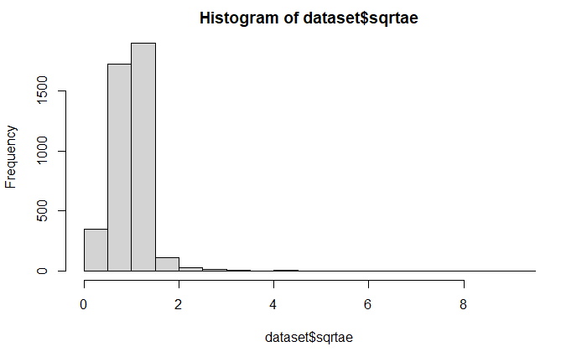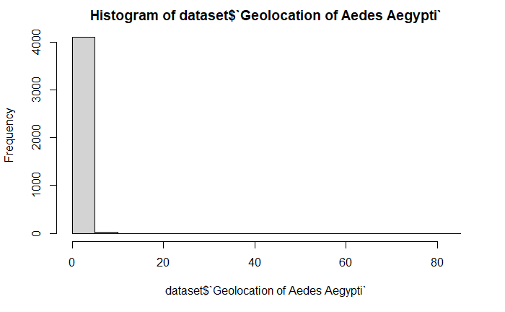  
Figure Histogram of Aedes Occurrences Figure Histogram of Square Root of Aedes Occurrences

**Square Root of Aedes Occurrences**

**Aedes Occurrences**

*Source: Author analysis, 2022*

#### 4.3.1.2 Precipitation

The summary of Average Precipitation (see Figure 9) shows that the mean and median look similar. In addition, the distribution curve shows a bell-shaped form (see Figure 10). Therefore, we conclude that Average Precipitation data is normally distributed

**Average Precipitation**

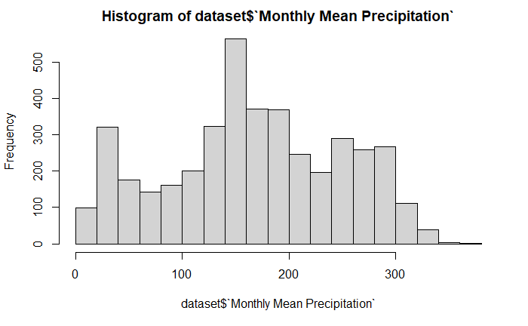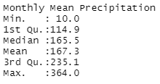

**Average Precipitation**

Figure Summary of Average Precipitation Figure Histogram of Average Precipitation

*Source: Author analysis, 2022*

#### 4.3.1.3 Temperature

The summary of Average Temperature (Figure 11) shows that the mean and median look similar. In addition, the distribution curve shows a bell-shaped form (Figure 12). Therefore, we conclude that Average Temperature data is normally distributed

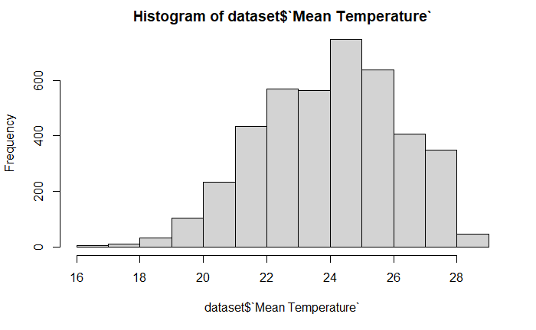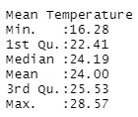

**Average Temperature**

**Average Temperature**

Figure Summary of Average Temperature Figure Histogram of Average Temperature

*Source: Author analysis, 2022*

#### 4.3.1.4 Population Density

The summary of Population Density (see Figure 13) shows that the mean and median does not look similar. In addition, the distribution curve (see Figure 14) depicts the data does not perform bell-shaped. Therefore, the author did log transformation to the population density data. The log transformation succeed to make the data normally distributed as the curve performs bell shaped (Figure 15)

**Population Density**

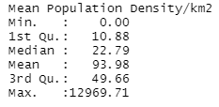

Figure Summary of Population Density

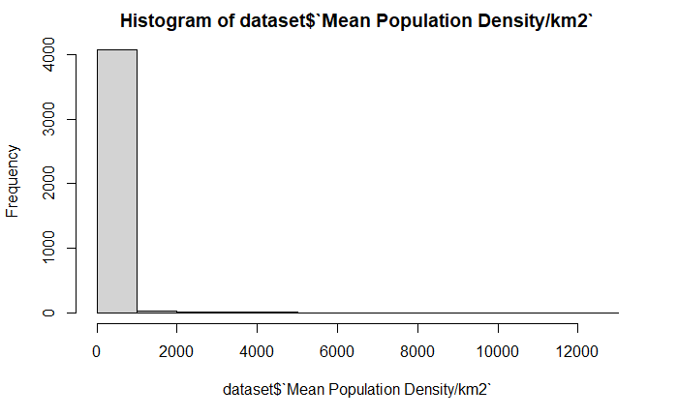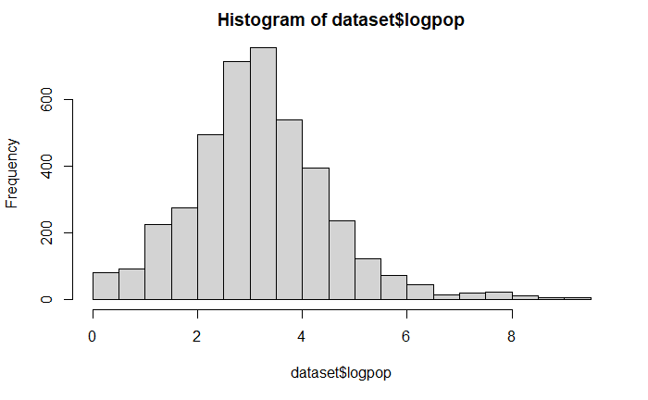

**Log Population Density**

**Population Density**

Figure Histogram of Population Density Figure Histogram of Log Population Density

*Source: Author analysis, 2022*

### 4.3.2 Correlation Test

To measure how independent variables are related to the dependent variable, the author used correlation test between Aedes Occurrences to Average Precipitation, Average Temperature and Population Density

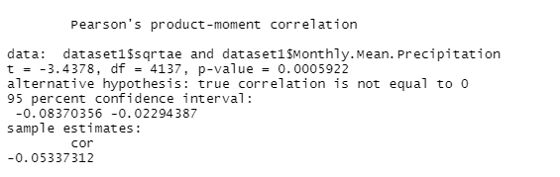

Figure Correlation Test Result between Square Root Aedes Occurrences and Average Precipitation

*Source: Author analysis, 2022*

Figure 16 depicts the result of Correlation Test between Square Root Aedes Occurrences and Average Precipitation. It shows that the correlation coefficient is -0.05 indicating that average precipitation has a very weak negative relationship with Aedes occurrences. The p-value is a small value which less than 0.05. Therefore, we conclude that this negative relationship is statistically significant

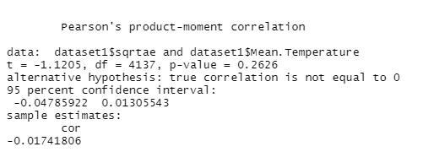

Figure Correlation Test Result between Square Root Aedes Occurrences and Average Temperature

*Source: Author analysis, 2022*

Figure 17 depicts the result of Correlation Test between Square Root Aedes Occurrences and Average Temperature. It shows that the correlation coefficient is -0.017 indicating that average temperature has a very weak negative relationship with Aedes occurrences. The p-value is more than 0.05. Therefore, we conclude that this negative relationship is not statistically significant

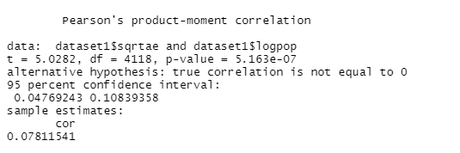

Figure Correlation Test Result between Square Root Aedes Occurrences and Population Density

*Source: Author analysis, 2022*

Figure 18 depicts the result of Correlation Test between Square Root Aedes Occurrences and Population Density. It shows that the correlation coefficient is 0.078 indicating that population density has a very weak positive relationship with Aedes occurrences. The p-value is a very small value which is far less than 0.05. Therefore, we conclude that this positive relationship is statistically significant

### 4.3.3 Multivariable Linear Regression Model

After doing normality and correlation test, the author run a multivariable linear regression analysis which assigns Square Root Aedes Occurrences as dependent variable and Log Population Density, Average Temperature and Average Precipitation as independent variables.

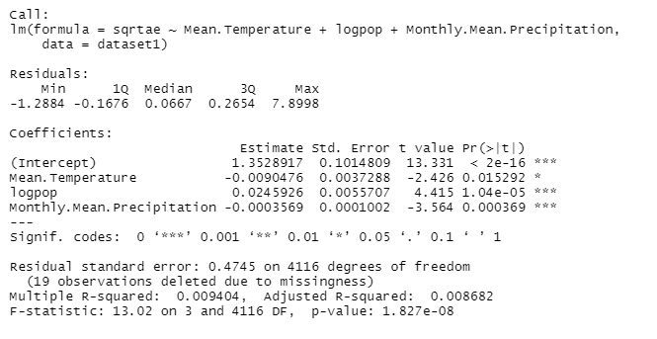

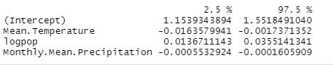

Figure Multivariable Linear Regression Result

Figure 18 show the result of multivariable linear regression with 95% of confidence interval. The square root of Aedes occurrences, on average, are 1.35 (95% CI: 1.153 to 1.55; p < 0.001) when Average Precipitation, Average Temperature, and Log Population Density are equal to zero. For every unit increase in the average precipitation, the square root of Aedes Occurrences decreases on average by 0.0003 (95% CI: -0.0005 to -0.0001; p <0.001). For every unit increase in average temperature, there’s a marginal decrease for the square root of on average by -0.002 (95% CI: -0.0025 to -0.0019; p >0.05). For every unit increase in Log Population Density, the square root of Aedes Occurrences increases on average by 0.024 (95% CI: 0.013 to 0.035; p <0.001). R-squared is 0.0086 which indicates that 0.8% of the variation in square root of Aedes occurrences is explained using average precipitation, average temperature and log population density. The result indicates the poor model but that does not mean the model is invalid. The regression equation is:

# Discussion

Based on correlation test and regression modelling, we can see that average precipitation has negative correlation with Aedes occurrence significantly, while population density has positive correlation. That means lower precipitation and higher population density will affect to the higher Aedes occurrences. These findings are in line with Dickens et al (2018) which stated that population density has positive correlation with Aedes occurrences. Meanwhile, finding on negative correlation of precipitation contradicts to Sallam et al (2017) evidence. This study finds insignificant result of the correlation between average temperature and Aedes occurrences. The author, therefore, used the previous studies about exact number of suitable temperature that positively affect Aedes occurrences. Studies found that temperatures between 20°C and 31°C is ideal for the habitat of Aedes (Scott et al., 2000; Araujo et al., 2015; Misslin et al., 2016; Murdock et al., 2017).

This study attempted to identify which municipalities have high suitability for Aedes habitat by overlaying the map of variables. Each of map sorted the municipalities based on the suitability criteria; low category of precipitation (yellow area on Figure 3), high level of population density (red area on Figure 5) and temperature of 20 to 31 degree celcius (orange and red area on Figure 4). The result of the overlay map is presented on Figure 20. The overlay analysis results 14 municipalities that met the criteria of high suitability habitat according to regression model and literature review (see red area on Figure 20). Those are Anahy, Umuarama, Madre de deus, Lauro de Freitas, Campina Grande, Belem, Macae, Poco Fundo, Salvador, Forquilha, Ribeirao das Neves, Jussara and Mataraca. They are mostly located in the coastal area of Brazil.

This study has limitation in terms of data collection, while the author did not incorporate land cover data such as built area and vegetation index and socioeconomic data such as income level. Whereas (Honório et al., 2009; Lorenz, Castro, et al., 2020) stated that urbanization and vegetation cover area has correlation with the Aedes prevalence, as well as Sallam et al., (2017) which found the influence of socio and economic aspect in Aedes presence. High resolution land cover data could only be obtained in more detail scale such as in the state level, while that does not fit with the aim of this study that focus on habitat suitability in the scope country level. Therefore, further study needs to take more precise scale and cover more possible habitat suitability variables.

However, despite the limitation, the finding of this study could help national government to predict the high risk municipalities of Aedes disease in particular time. Having the information of high risk area helps prepare government to do preparedness action such as spraying of resting sites of Aedes and strengthening the capacity of regional healthcare in those area (WHO, 2016). This study finds the benefit of environmental open data (i.e. climate and population data) utilization for public health emergency. This method will be an opportunity to predict any other diseases trigger by environmental variables.

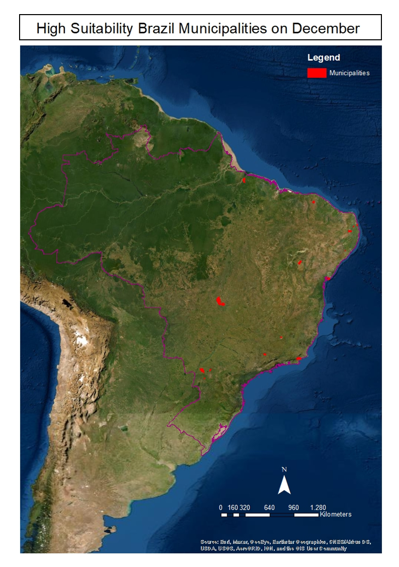

Boundary of Brazil

**High Suitability of Aedes Habitat in Brazil on December**

Figure High Suitability Map of Aedes Habitat in Brazil on December

*Source: Author analysis, 2022*

# Conclusion

This study provides the map and relationship model of Aedes habitat suitability in Brazil. Result shows that on December, low precipitation and high density of population significantly influence the number of Aedes occurrences. However, temperature is not statistically significant in affecting the occurrences of Aedes on December. Based on the model and previous study, the author found 14 municipalities that have high suitability on Aedes occurrences. This finding is important as basis to take prevention and preparedness action in national or regional scale. In addition, this study demonstrates the utility of high-gridded data as approach in identifying risk area of health disaster, which is really potential to be used in other mosquito-borne diseases.

# References

Araujo, R.V., Albertini, M.R., Costa-da-Silva, A.L., Suesdek, L., Franceschi, N.C.S., Bastos, N.M., Allegro, V.L.A.C., 2015. São Paulo urban heat islands have a higher incidence of dengue than other urban areas. Braz. J. Infect. Dis. 19 (2), 146–155.

Chadee, D.D., 2004. Key premises, a guide to Aedes aegypti (Diptera: Culicidae) surveillance and control. Bull. Entomol. Res. 94 (3), 201–207.

Dickens, B. L., Sun, H., Jit, M., Cook, A. R., & Carrasco, L. R. (2018). Determining environmental and anthropogenic factors which explain the global distribution of *Aedes aegypti* and *Ae. Albopictus*. *BMJ Global Health*, *3*(4), e000801. https://doi.org/10.1136/bmjgh-2018-000801

Figueiredo, L. T. M. (2003). *Dengue in Brazil: Past, Present and Future Perspective*. *27*, 9.

Focks, D.A., Chadee, D.D., 1997. Pupal survey: an epidemiologically signiﬁcant surveillance method for Aedes aegypti: an example using data from Trinidad. Am. J. Trop. Med. Hyg. 56 (2), 159–167.

Gubler, D.J., 1998. Dengue and dengue hemorrhagic fever. Clin. Microbiol. Rev. 11 (3), 480–496.

Honório, N. A., Castro, M. G., Barros, F. S. M. de, Magalhães, M. de A. F. M., & Sabroza, P. C. (2009). The spatial distribution of Aedes aegypti and Aedes albopictus in a transition zone, Rio de Janeiro, Brazil. *Cadernos de Saúde Pública*, *25*(6), 1203–1214. https://doi.org/10.1590/S0102-311X2009000600003

Healey, Joseph F. 2010. Statistics: A Tool for Social Research Ninth Edition. Wadsworth, Cengage Learning

Ibáñez-Justicia, A., Alcaraz-Hernández, J. D., van Lammeren, R., Koenraadt, C. J. M., Bergsma, A., Delucchi, L., Rizzoli, A., & Takken, W. (2020). Habitat suitability modelling to assess the introductions of Aedes albopictus (Diptera: Culicidae) in the Netherlands. *Parasites & Vectors*, *13*(1), 217. https://doi.org/10.1186/s13071-020-04077-3

Kyle, J.L., Harris, E., 2008. Global spread and persistence of dengue. Annu. Rev. Microbiol. 62, 71–92.

Kraemer MUG, Sinka ME, Duda KA, Mylne AQN, Shearer FM, Brady OJ, Messina JP, Barker CM, Moore CG, Carvalho RG, Coelho GE, Van Bortel W, Hendrickx G, Schaffner F, Wint GRW, Elyazar IRF, Teng H-J, Hay SI. 2015a. The global compendium of Aedes aegypti and Ae. albopictus occurrence. Scientific Data 2:150035. doi: 10.1038/sdata.2015.35

Kraemer MUG, Sinka ME, Duda KA, Mylne AQN, Shearer FM, Brady OJ, Messina JP, Barker CM, Moore CG, Carvalho RG, Coelho GE, Van Bortel W, Hendrickx G, Schaffner F, Wint GRW, Elyazar IRF, Teng H-J, Hay SI. 2015b. The global distribution of the arbovirus vectors Aedes aegypti and Ae. albopictus. doi: 10.7554/eLife.08347

Lorenz, C., Castro, M. C., Trindade, P. M. P., Nogueira, M. L., de Oliveira Lage, M., Quintanilha, J. A., Parra, M. C., Dibo, M. R., Fávaro, E. A., Guirado, M. M., & Chiaravalloti-Neto, F. (2020). Predicting Aedes aegypti infestation using landscape and thermal features. *Scientific Reports*, *10*(1), 21688. https://doi.org/10.1038/s41598-020-78755-8

Lorenz, C., Chiaravalloti-Neto, F., de Oliveira Lage, M., Quintanilha, J. A., Parra, M. C., Dibo, M. R., Fávaro, E. A., Guirado, M. M., & Nogueira, M. L. (2020). Remote sensing for risk mapping of Aedes aegypti infestations: Is this a practical task? *Acta Tropica*, *205*, 105398. https://doi.org/10.1016/j.actatropica.2020.105398

Lubinda, J., Treviño C., J. A., Walsh, M. R., Moore, A. J., Hanafi-Bojd, A. A., Akgun, S., Zhao, B., Barro, A. S., Begum, M. M., Jamal, H., Angulo-Molina, A., & Haque, U. (2019). Environmental suitability for Aedes aegypti and Aedes albopictus and the spatial distribution of major arboviral infections in Mexico. *Parasite Epidemiology and Control*, *6*, e00116. https://doi.org/10.1016/j.parepi.2019.e00116

Luz, P. M., C. T. Codeco, E. Massad, and C. J. Struchiner. 2003. Uncertainties regarding dengue modelling in Rio de Janeiro, Brazil. Mem. Inst. Oswaldo Cruz 98: 871Ð878

Misslin, R., Telle, O., Daudé, E., Vaguet, A., Paul, R.E., 2016. Urban climate versus global climate change–what makes the diﬀerence for dengue? Ann. N.Y. Acad. Sci. 1382 (1), 56–72.

MS, Brazilian Public Health, 2019. Available from <http://portalsaude.saude.gov.br>.

Murdock, C.C., Evans, M.V., McClanahan, T.D., Miazgowicz, K.L., Tesla, B., 2017. Finescale variation in microclimate across an urban landscape shapes variation in mosquito population dynamics and the potential of Aedes albopictus to transmit arboviral disease. PLoS Negl. Trop. Dis. 11 (5), e0005640.

Omar, K., Thabet, H. S., TagEldin, R. A., Asadu, C. C., Chukwuekezie, O. C., Ochu, J. C., Dogunro, F. A., Nwangwu, U. C., Onwude, O. C., Ezihe, E. K., Anioke, C. C., & Arimoto, H. (2021). Ecological niche modeling for predicting the potential geographical distribution of Aedes species (Diptera: Culicidae): A case study of Enugu State, Nigeria. *Parasite Epidemiology and Control*, *15*, e00225. https://doi.org/10.1016/j.parepi.2021.e00225

Paupy, C., Ollomo, B., Kamgang, B., Moutailler, S., Rousset, D., Demanou, M., Simard, F., 2010. Comparative role of Aedes albopictus and Aedes aegypti in the emergence of Dengue and Chikungunya in central Africa. Vector-Borne Zoonot. Dis. 10 (3), 259–266.

Proestos, Y., Christophides, G. K., Ergüler, K., Tanarhte, M., Waldock, J., & Lelieveld, J. (2015). Present and future projections of habitat suitability of the Asian tiger mosquito, a vector of viral pathogens, from global climate simulation. *Philosophical Transactions of the Royal Society B: Biological Sciences*, *370*(1665), 20130554. https://doi.org/10.1098/rstb.2013.0554

Sallam, M., Fizer, C., Pilant, A., & Whung, P.-Y. (2017). Systematic Review: Land Cover, Meteorological, and Socioeconomic Determinants of Aedes Mosquito Habitat for Risk Mapping. *International Journal of Environmental Research and Public Health*, *14*(10), 1230. https://doi.org/10.3390/ijerph14101230

Service, M.W., 1992. Importance of ecology in Aedes aegypti control. Southeast Asian J. Trop. Med. Public Health 23 (4), 681.

Scott, T.W., Amerasinghe, P.H., Morrison, A.C., Lorenz, L.H., Clark, G.G., Strickman, D., Edman, J.D., 2000. Longitudinal studies of Aedes aegypti (Diptera: Culicidae) in Thailand and Puerto Rico: blood feeding frequency. J. Med. Entomol. 37 (1), 89–101.

Tauil, P. 2001. Urbanizac¸a˜o e ecologia do dengue. Cad. Sau´de Pu´ bl. 17: 99Ð102.

WHO. 2016. Dengue Prevention and Control. World Health Organization for Western Part

Wilke, A. B. B., Vasquez, C., Carvajal, A., Medina, J., Chase, C., Cardenas, G., Mutebi, J.-P., Petrie, W. D., & Beier, J. C. (2020). Proliferation of Aedes aegypti in urban environments mediated by the availability of key aquatic habitats. *Scientific Reports*, *10*(1), 12925. https://doi.org/10.1038/s41598-020-69759-5

World Population Review. 2021. Brazil Population 2021. https://worldpopulationreview.com/countries/brazil-population